11/11/26 notes on a version of the model with:

No negative beliefs, memory of 24

Overview
A key determinant of performance in our model is communication.
A large quantity of outdated information kills that channel.
The ability to communicate negative beliefs is a way to counteract outdated information.
It turns out that, another way, is shrinking agents’ memory, with no negative beliefs.
Such model outperforms our baseline.
The intuition is that in our baseline mode, on steady state, most communication is about negative beliefs, which do not carry fresh information. With no negative belief and little memory, agents are forced to communicate mostly current information, making each message more effective.
The recency rule is still necessary in all this.

How the model works without negative beliefs
 | Baseline model | No negative beliefs, memory of 24
Kinds of belief | “Rule exists” (positive) and “rule gone” (negative) | Positives only
Testing a held belief whose constraint has been retired | Belief flips to “rule gone” and stays in memory | Belief is deleted; nothing records that it was tested
Testing a held belief whose constraint is current | Confirmed; becomes the most recently updated belief | Same
Testing a new random constraint | Added as “rule exists” if it is current | Same
Knowledge-base capacity | 120 beliefs, positive and negatives | 24 beliefs, only positives
When memory is full (recency rule) | The least recently updated belief is evicted | Same

The capacity of 24 is not arbitrary: it is about the number of positive beliefs agents hold in steady state in the baseline model.

Performances
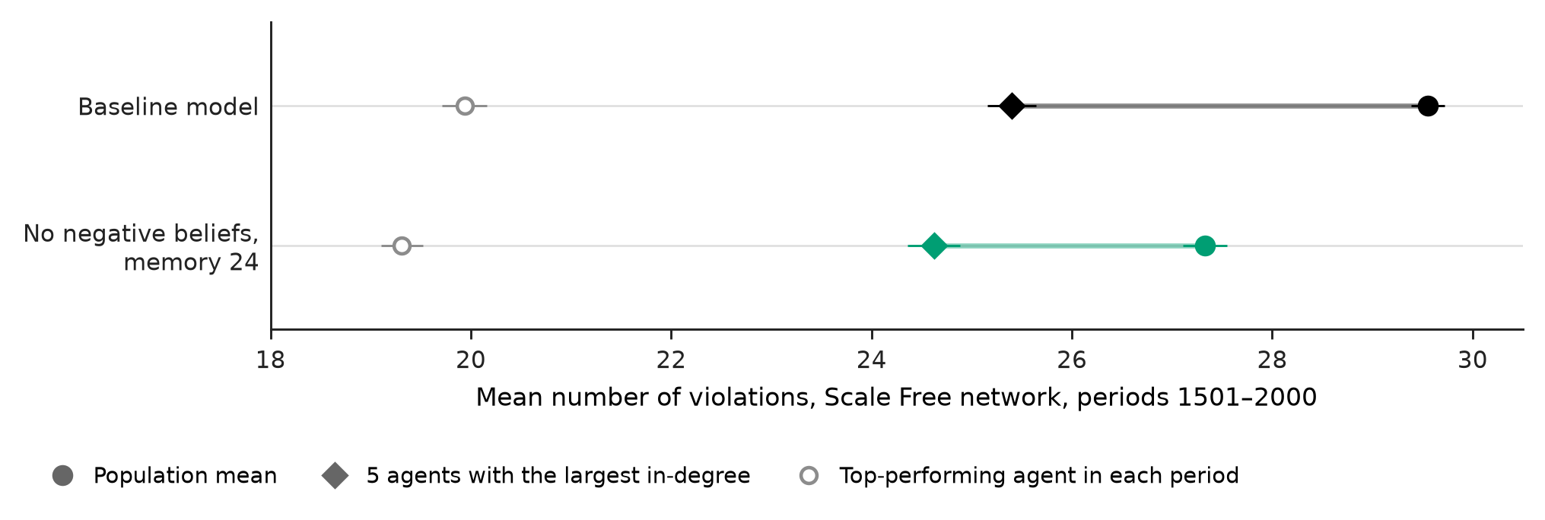
 | Regular, baseline | Regular, memory 24 | Scale Free, baseline | Scale Free, memory 24
Population mean | 28.6 | 25.7 | 29.6 | 27.3
5 agents with the largest in-degree | same as mean | same as mean | 25.4 | 24.6
5 agents with the fewest violations in periods 1001–1500 | 28.2 | 25.7 | 26.1 | 24.9
Top-performing agent in each period | 19.9 | 18.4 | 19.9 | 19.3
Homogeneity, H | 0.714 | 0.759 | 0.703 | 0.751

The gap between scale free and regular remains, it even grows a bit. So the trade-off between average performance and being able to identify structurally the best perormers remains.

Why does this model perform better? Information dynamics
Without negative beliefs but with a small memory, outdated beliefs disappear 2-3x faster than in the baseline. It becomes a model where information gets churned quickly and efficiently.
 | Regular, baseline | Regular, memory 24 | Scale Free, baseline | Scale Free, memory 24
Periods until no agent holds a retired constraint | 98 | 33 | 165 | 65
Periods a single agent keeps on average a retired constraint | 38 | 11 | 44 | 13

Both models deliver the same number of messages, about one per agent per period (due to normalisation); what changes is what the messages carry. Without negative beliefs, agents learn three to four times as many current constraints from their neighbour. Because that communication is not taken up by negative beliefs…
In the baseline steady state, most communication carries negative beliefs. Under the recency rule, a fresh falsification is an agent’s most recently updated belief, so it is the first thing passed on, to anyone who does not hold it. About four in five of these corrections reach agents that in fact never believed the constraint in the first place.


